**LAUNCH MYSQL RDS AND CONNECT:**

1. Create a VPC, Internet Gateway

2. Create 1 Public subnet and 2 private subnets in different AZs

3. Go to RDS -> Create DB Subnet group and add above 2 private subnets

4 Launch MySQL instance (db.t2.micro, Single AZ)

5 Go to RDS Security group and allow port 3306 access to VPC CIDR

6. Launch EC2 instance in Public Subnet with SSH (22) access for your IP

7. Login to EC2 over SSH and execute following commands (use your details)

> sudo yum install mysql

> mysql -h <your db instance endpoint> -P 3306 -u master -p

> show databases;

> use mydb:

> create table awstraining (name VARCHAR(30), batch INT(2), phone VARCHAR(10), email

VARCHAR(30);

> insert into awstraining values ((‘Shrikanth C R’, 2, 8884420120, 'shrikanthcr888@amail.com'):

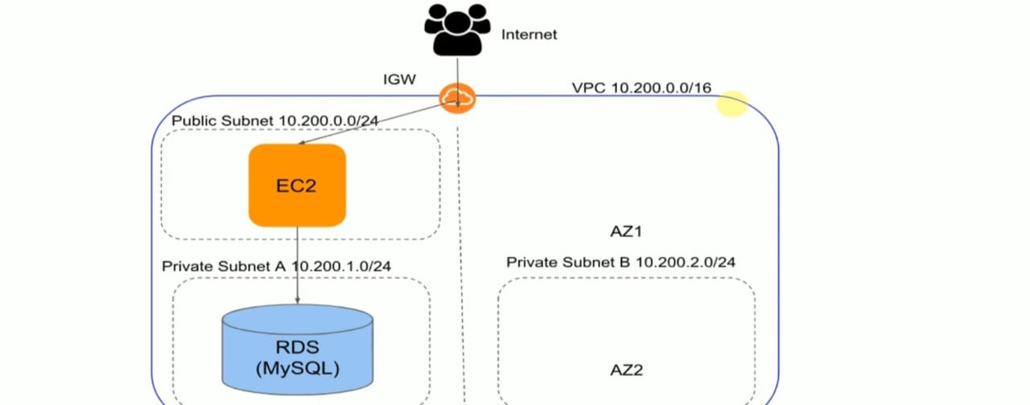

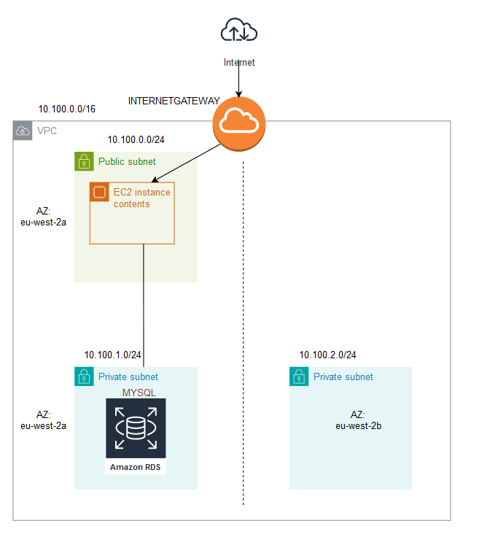

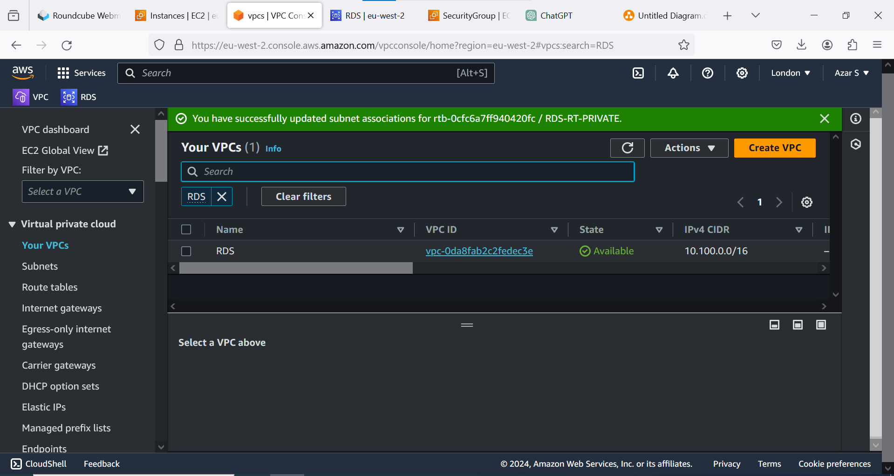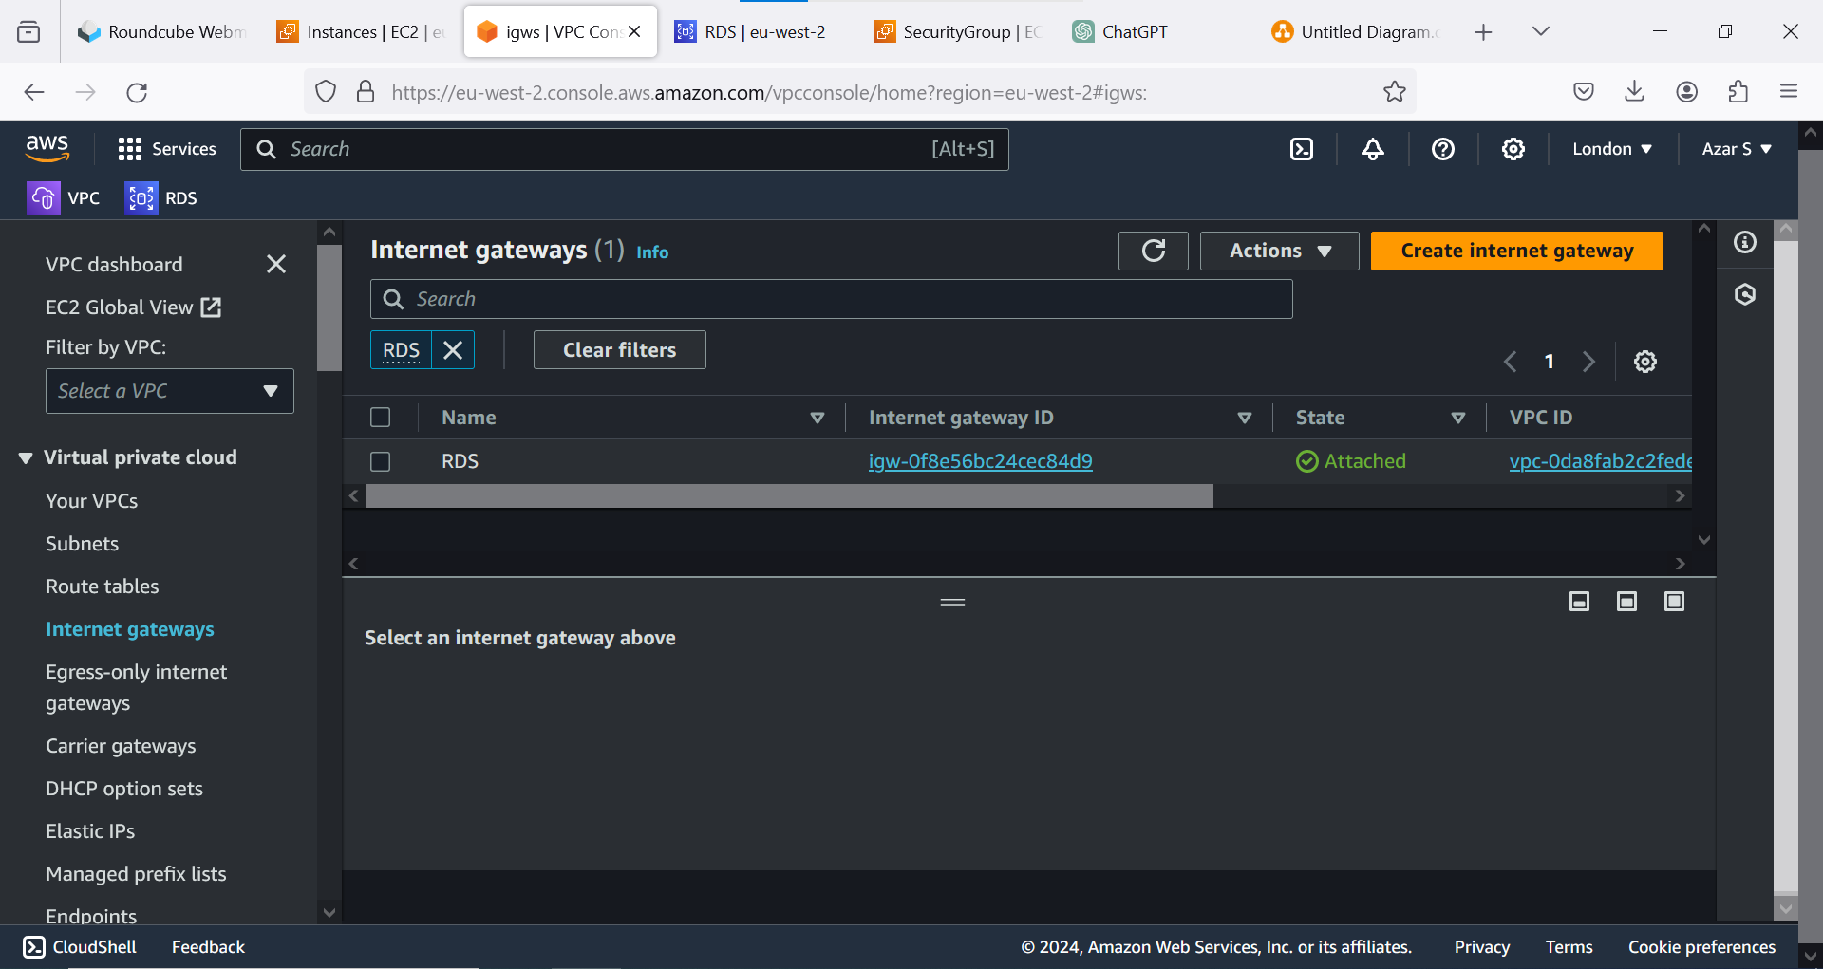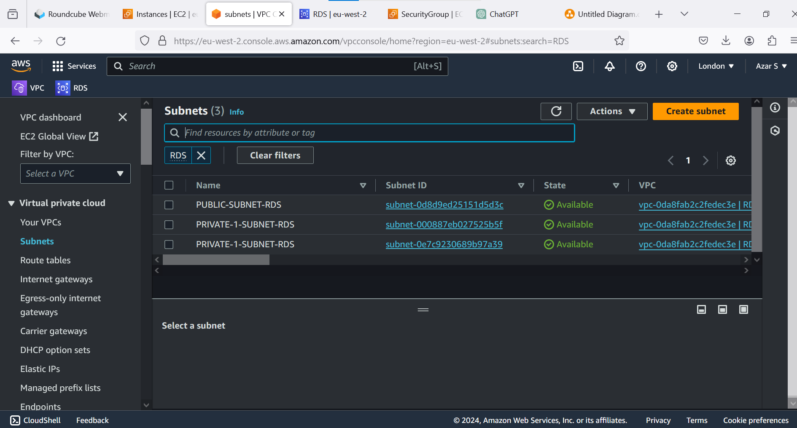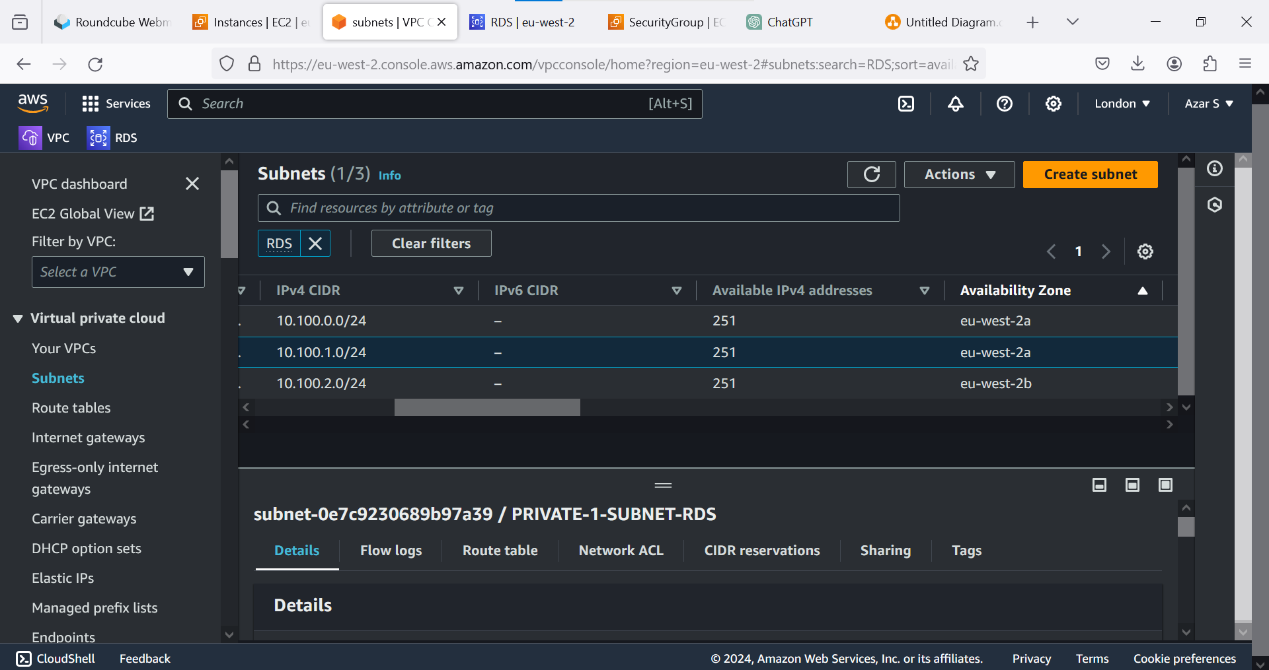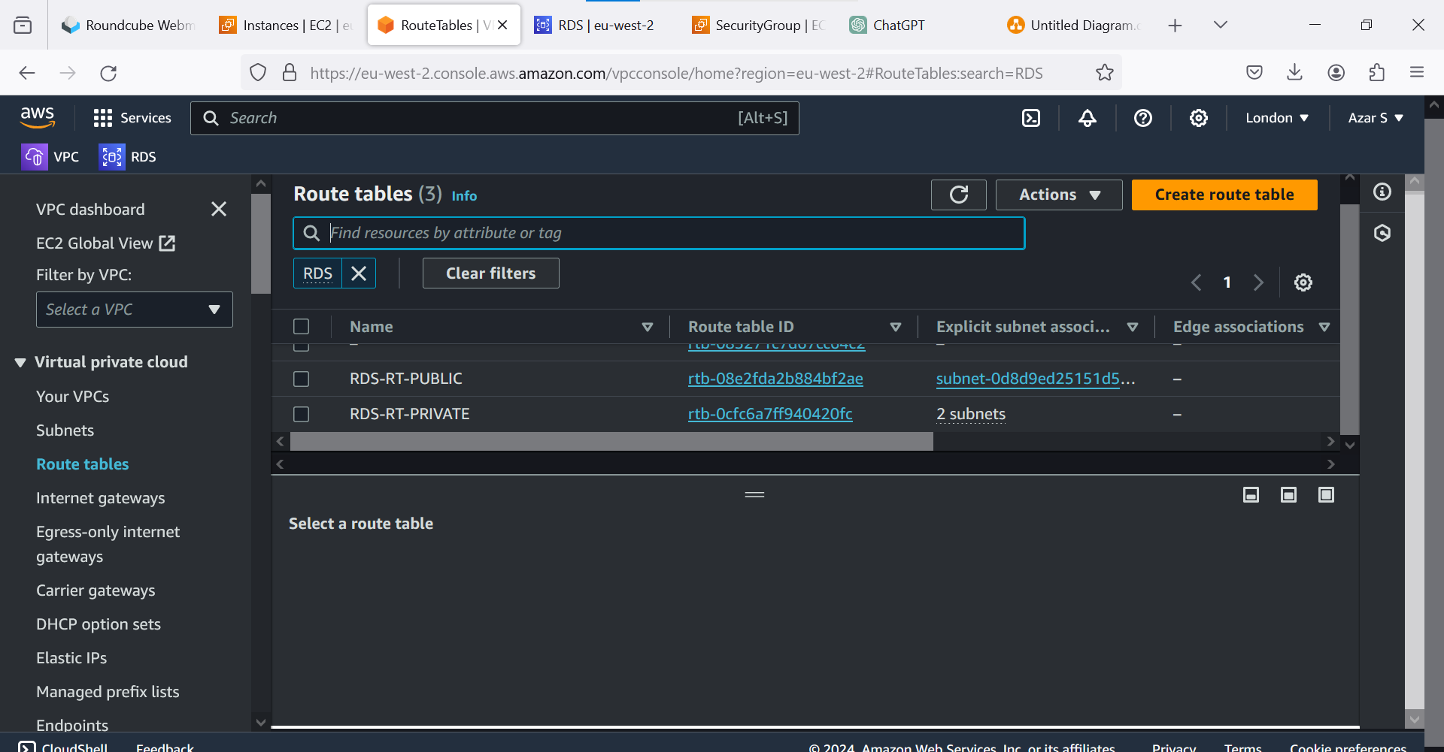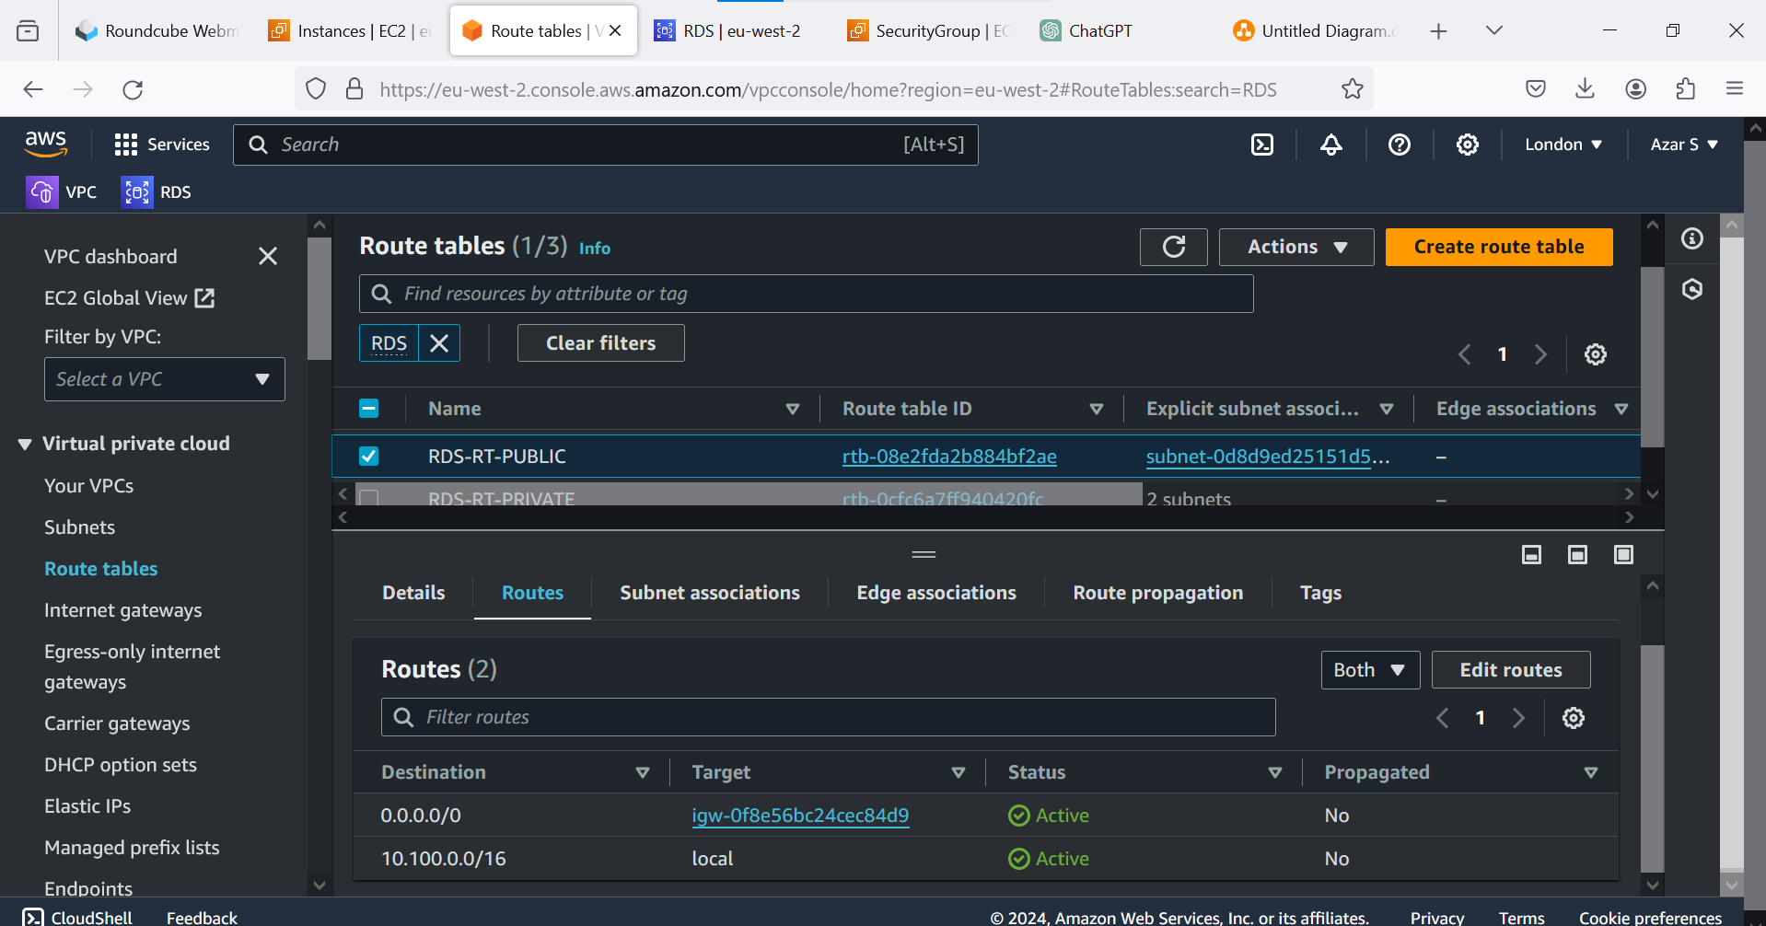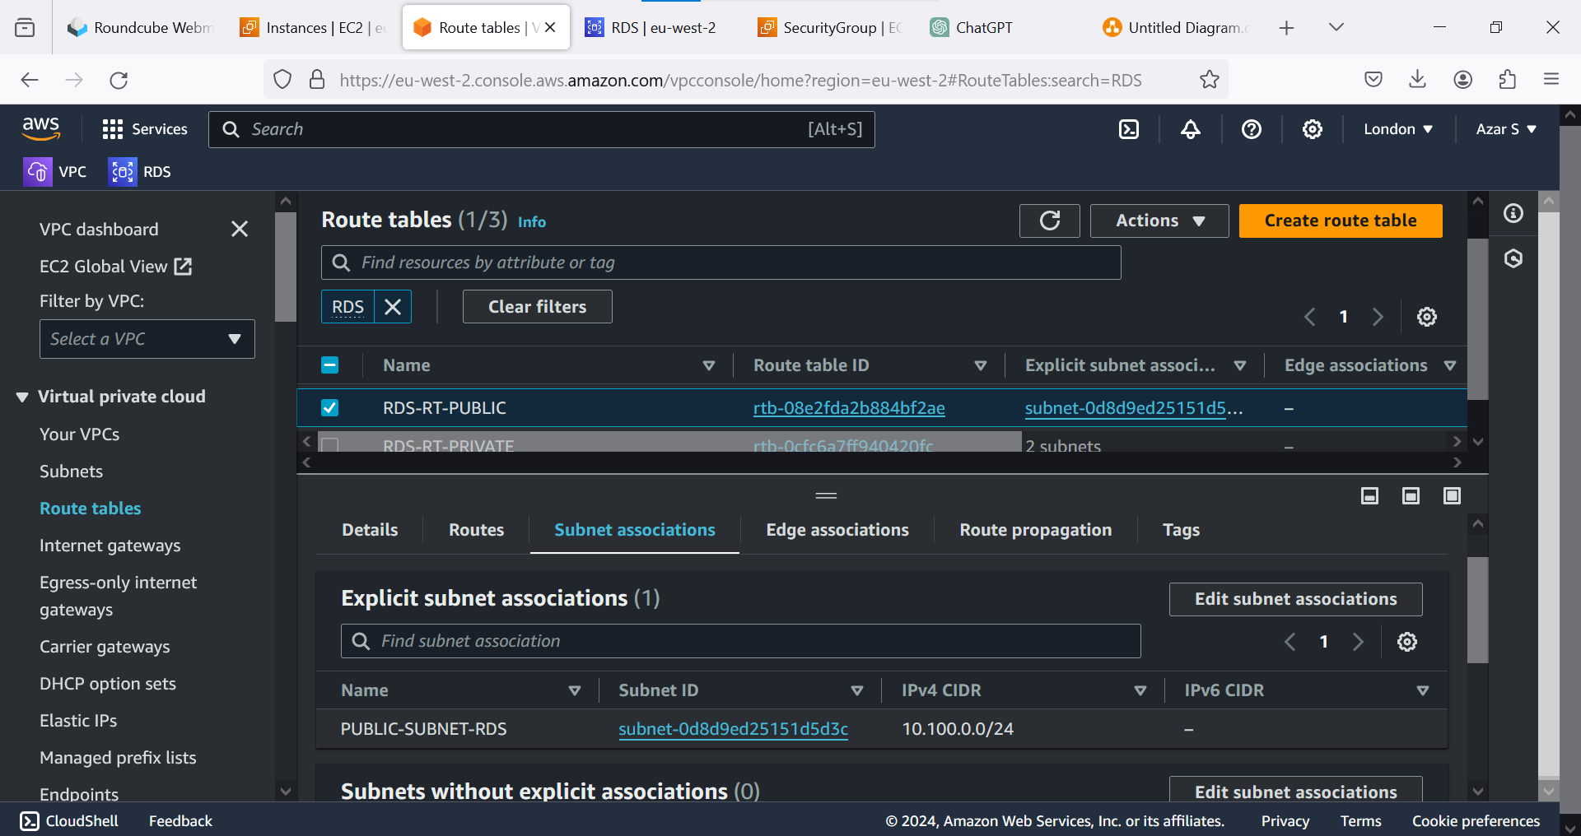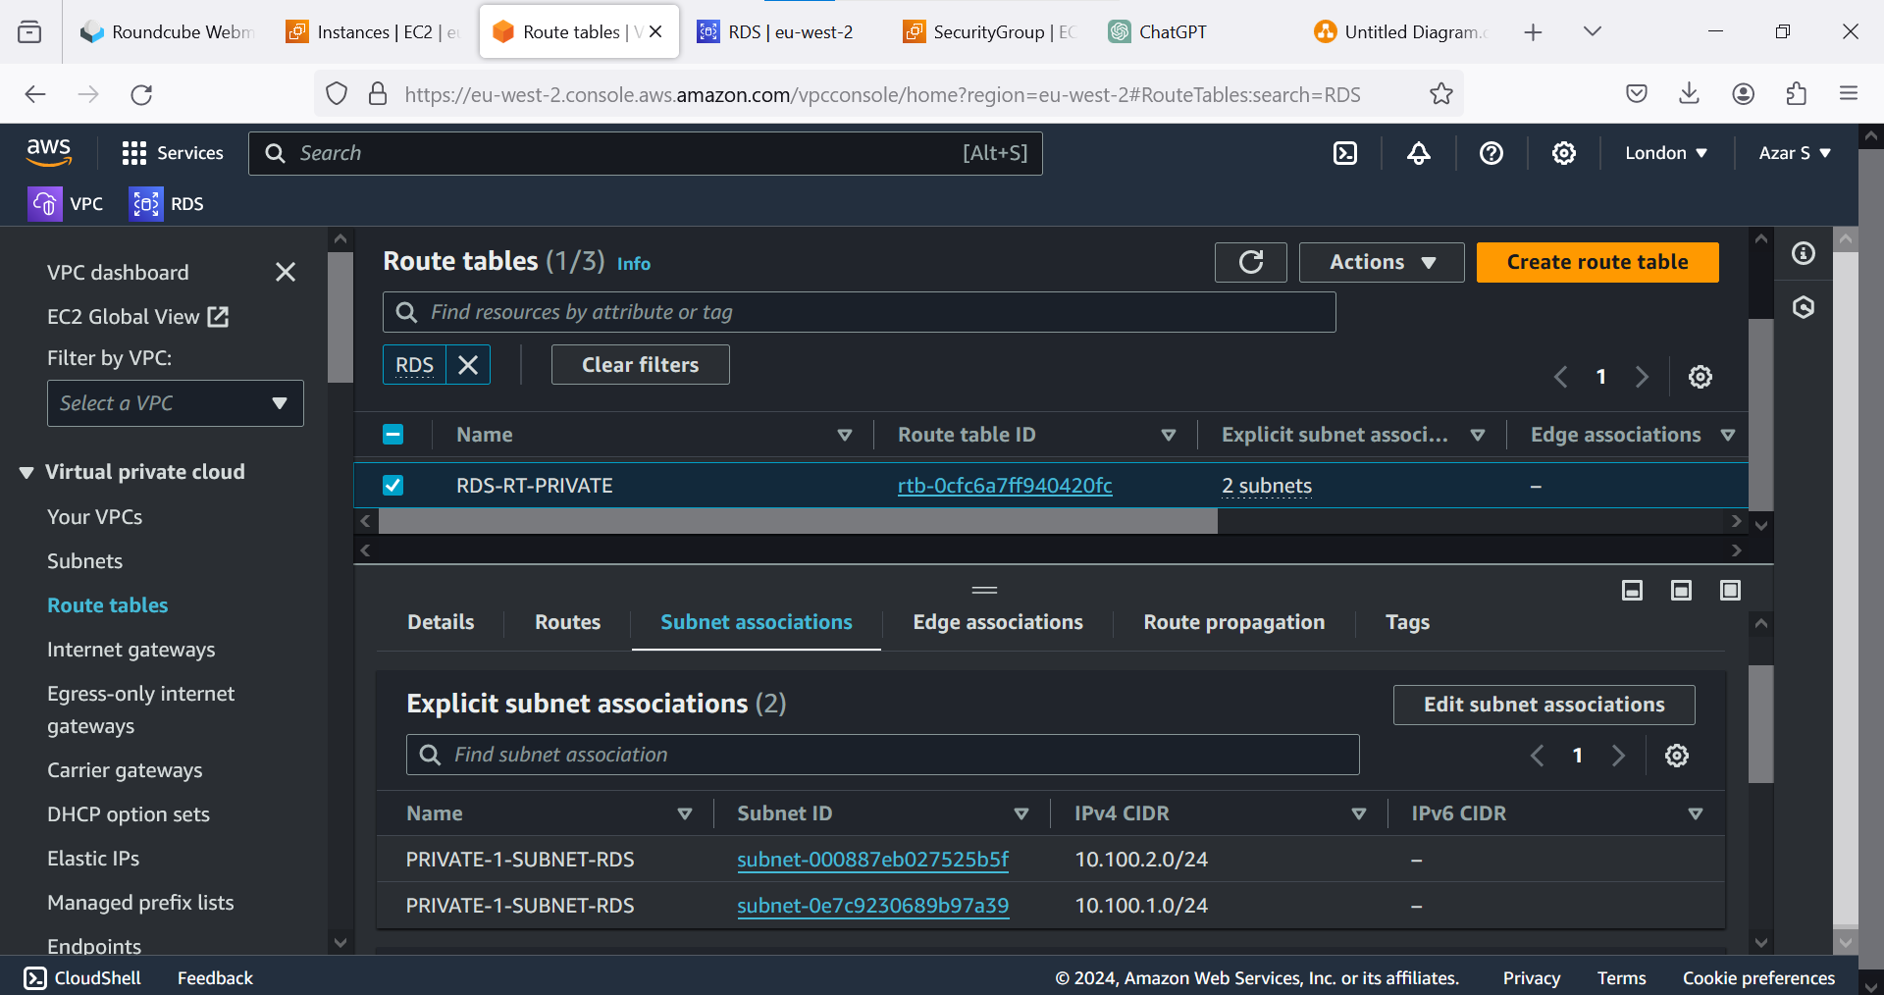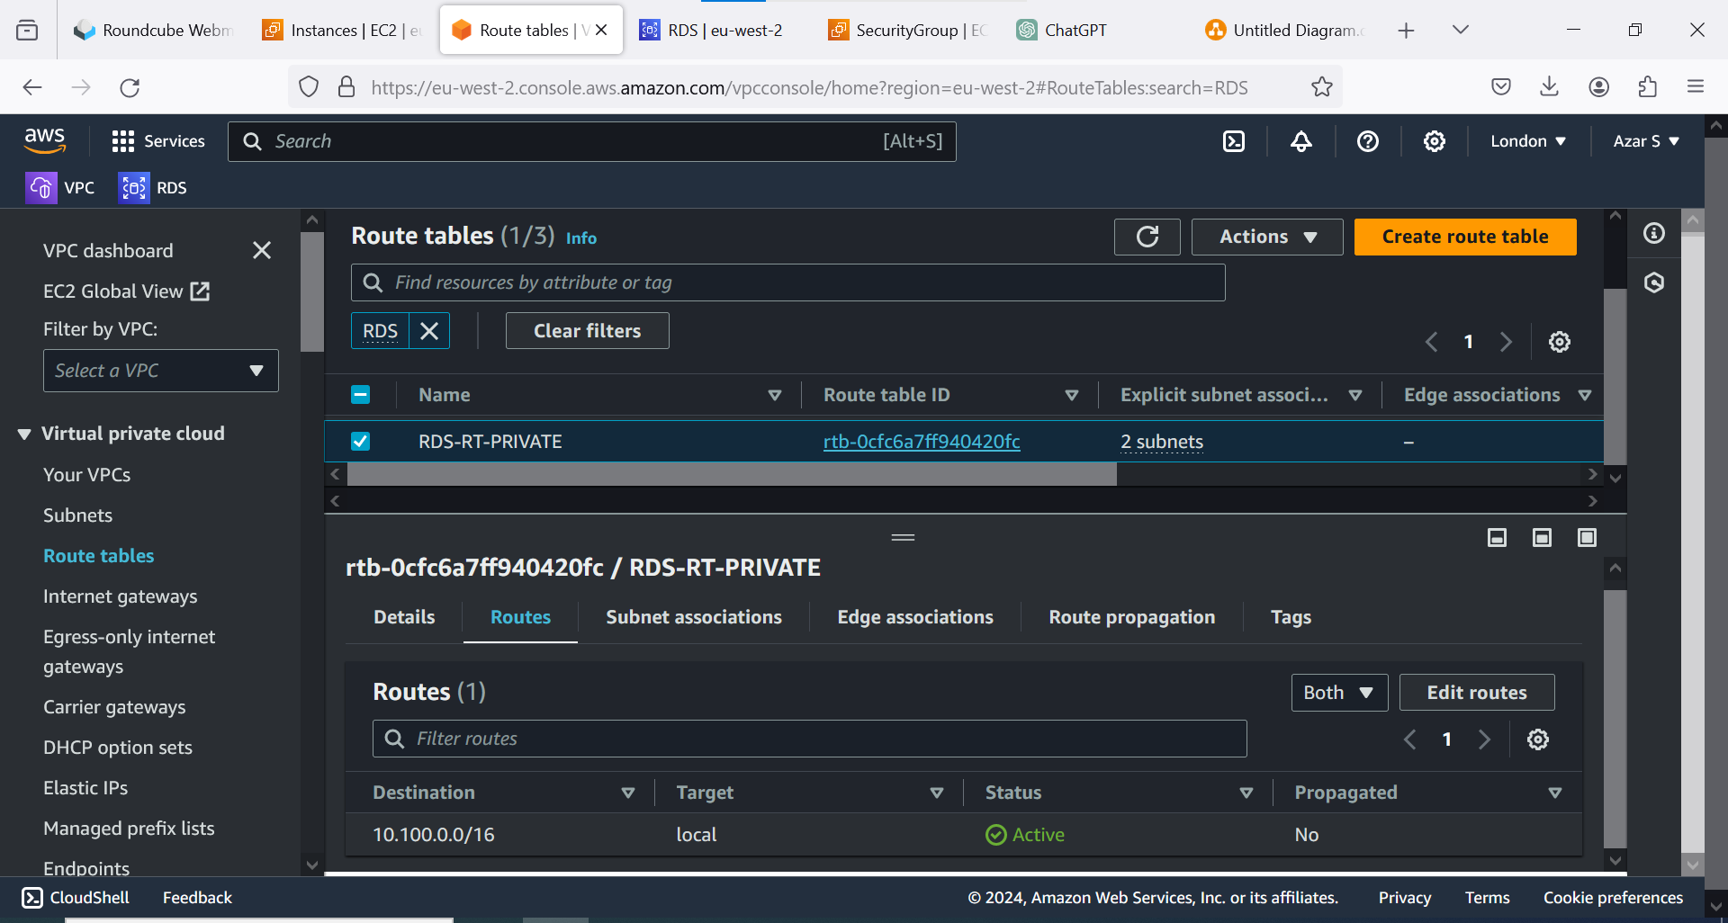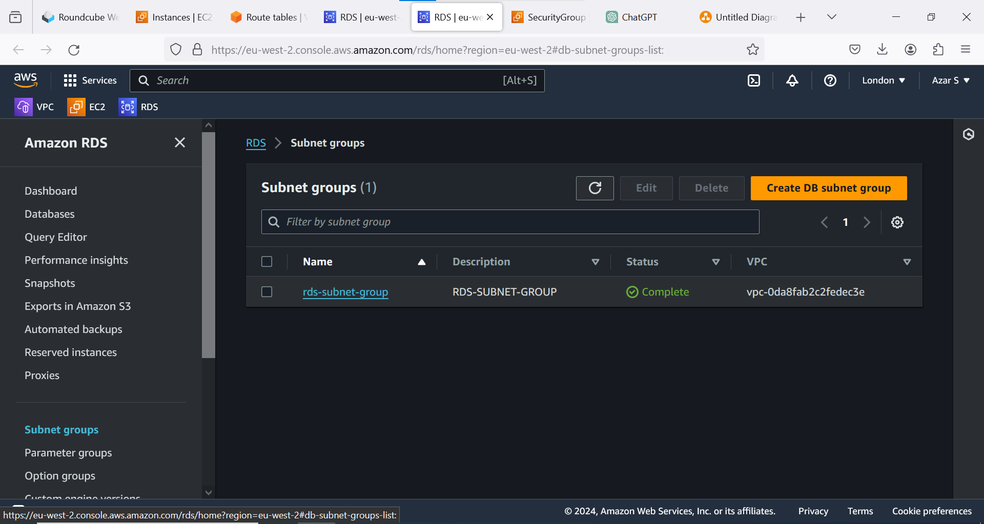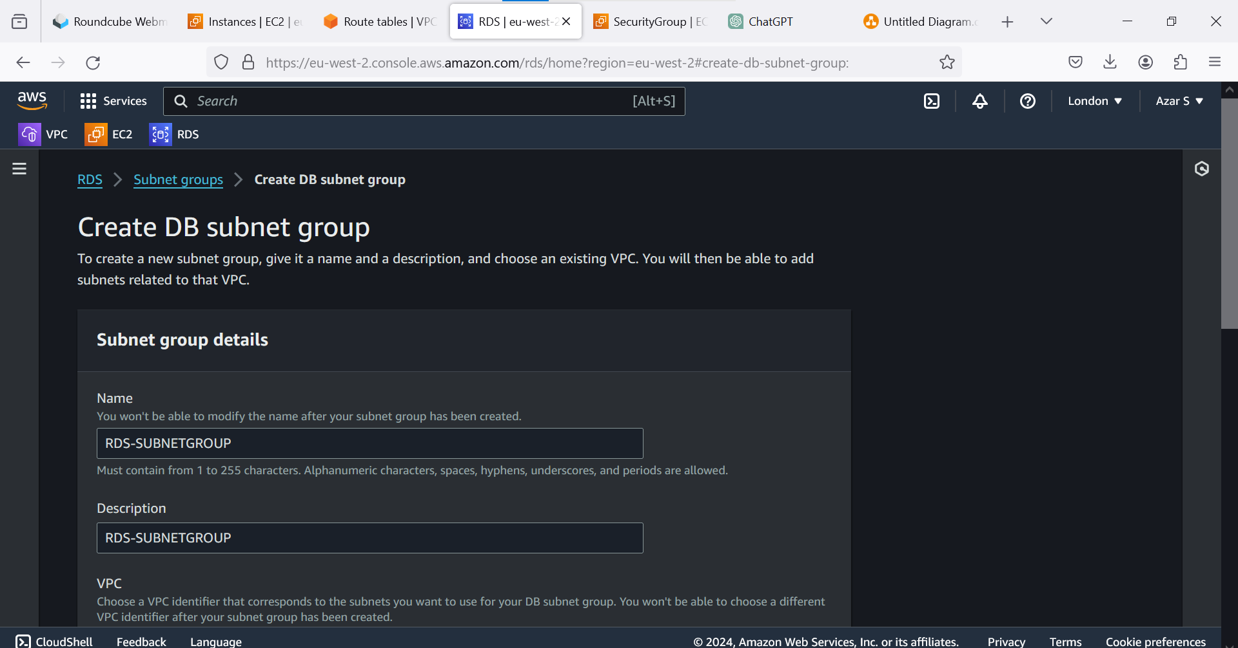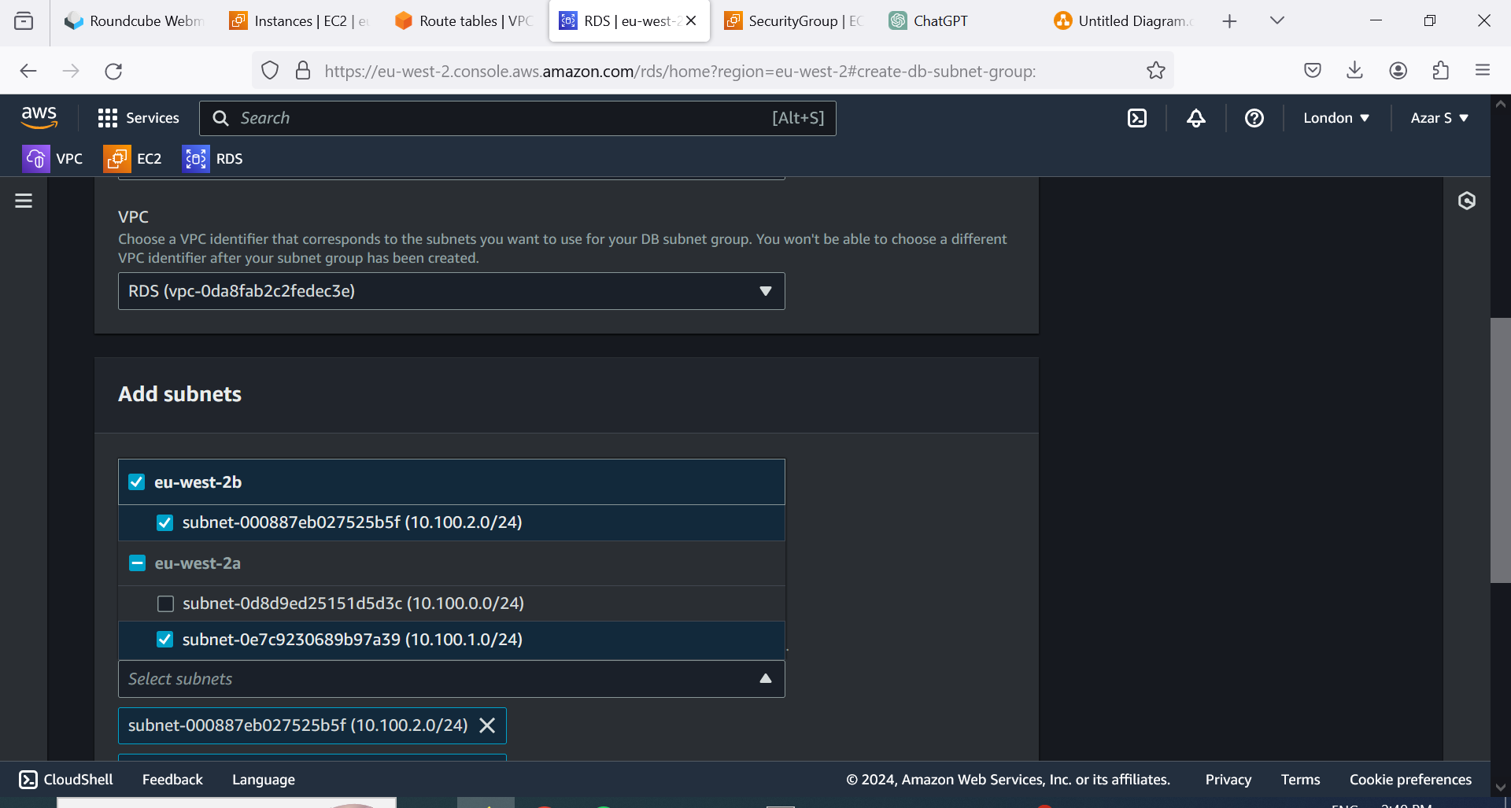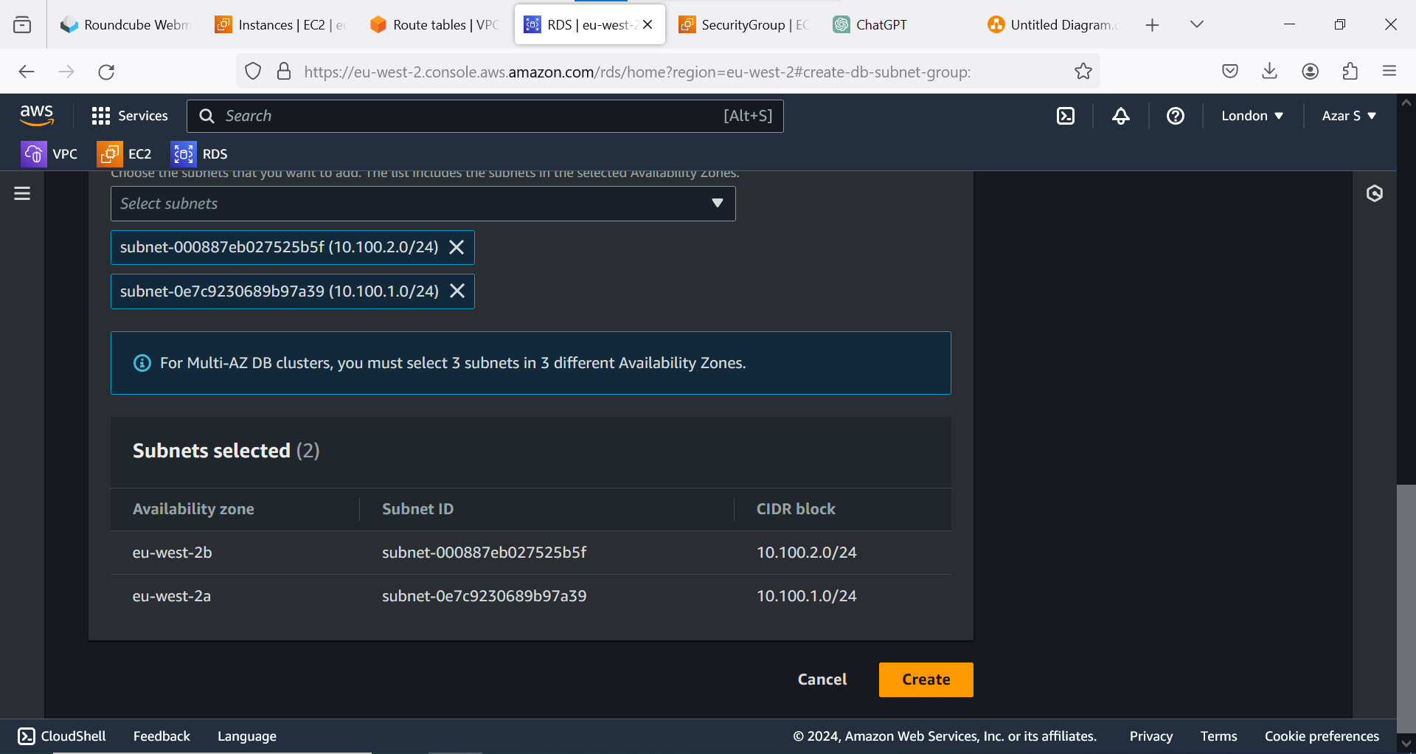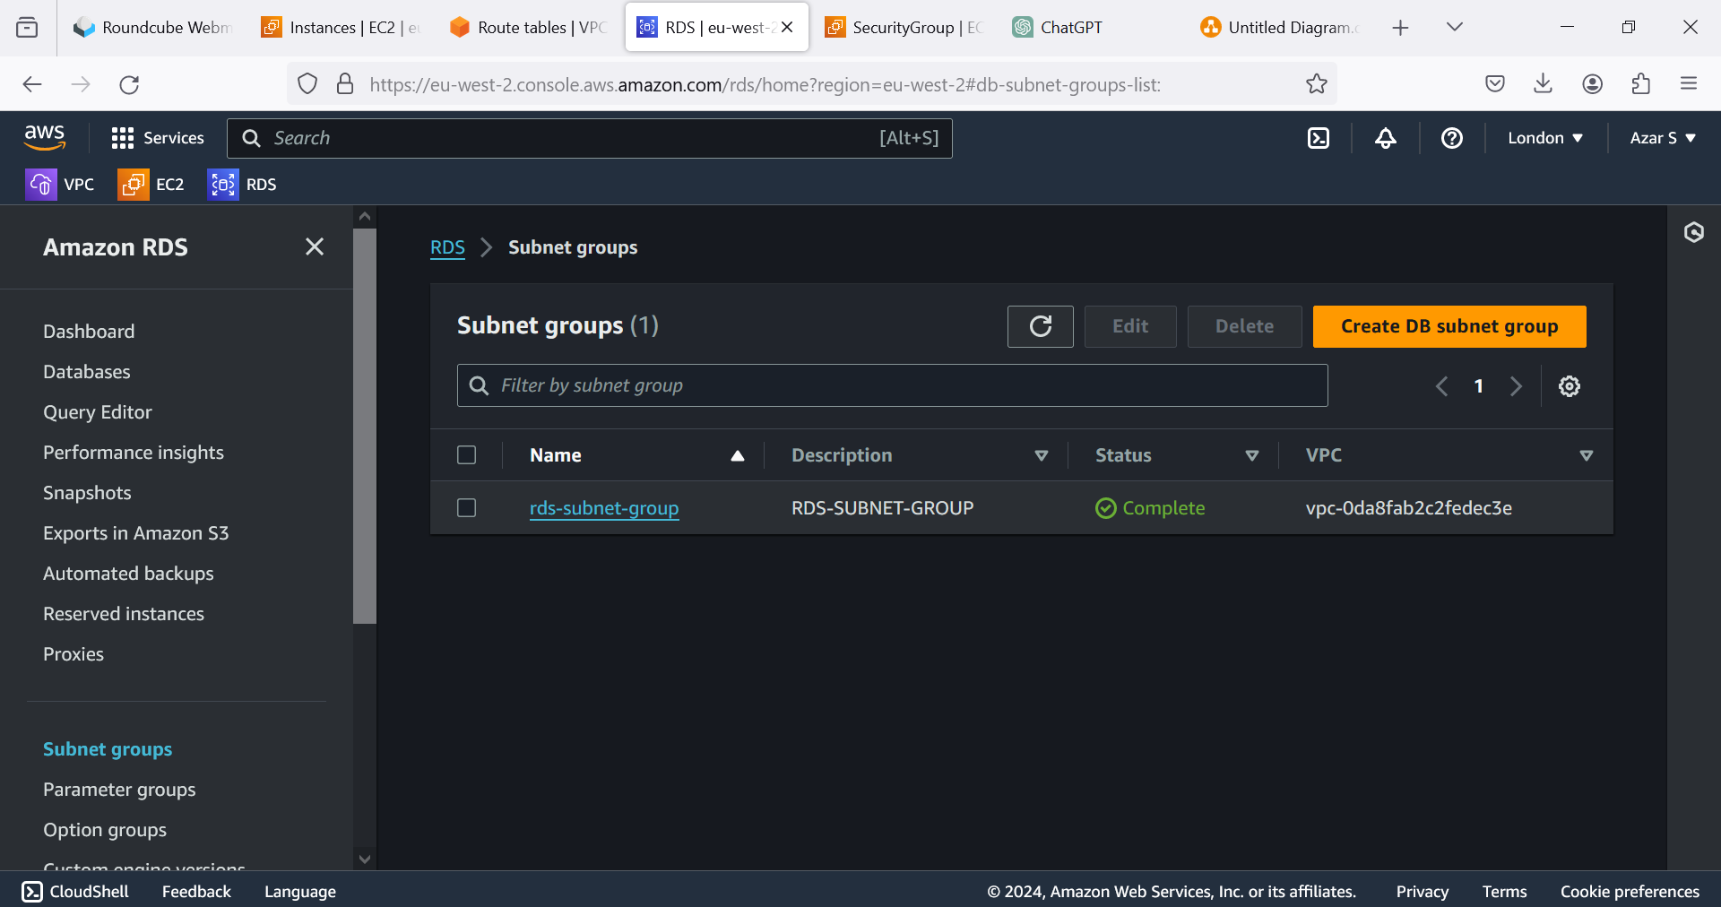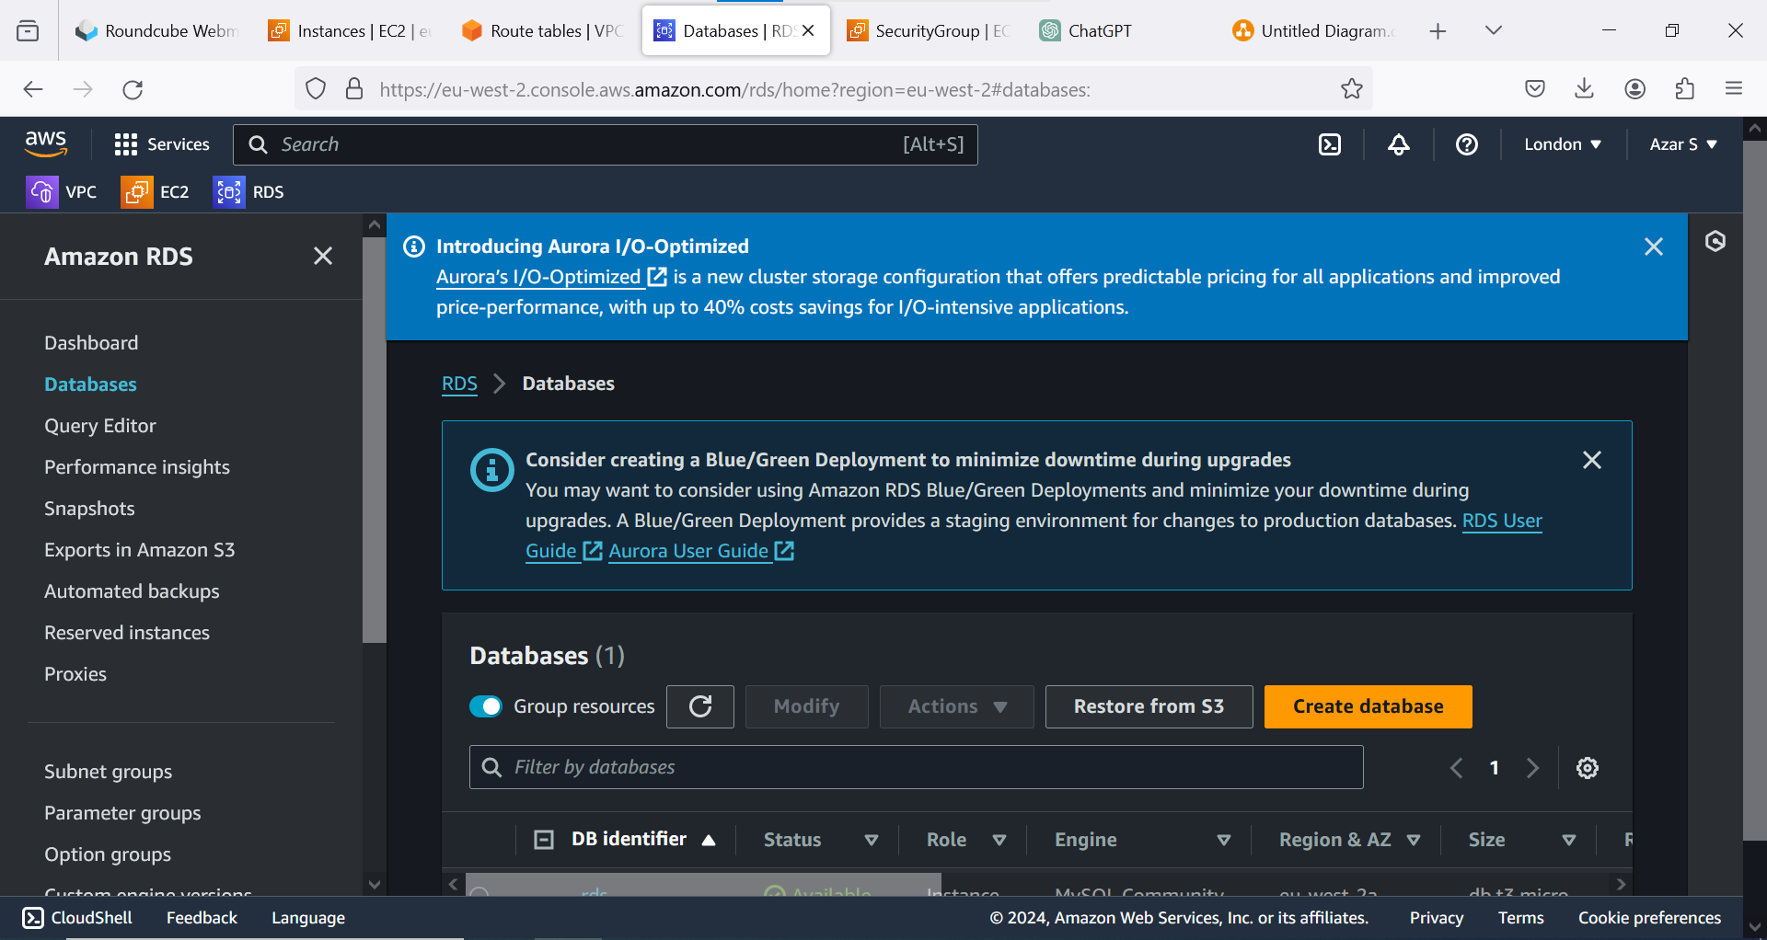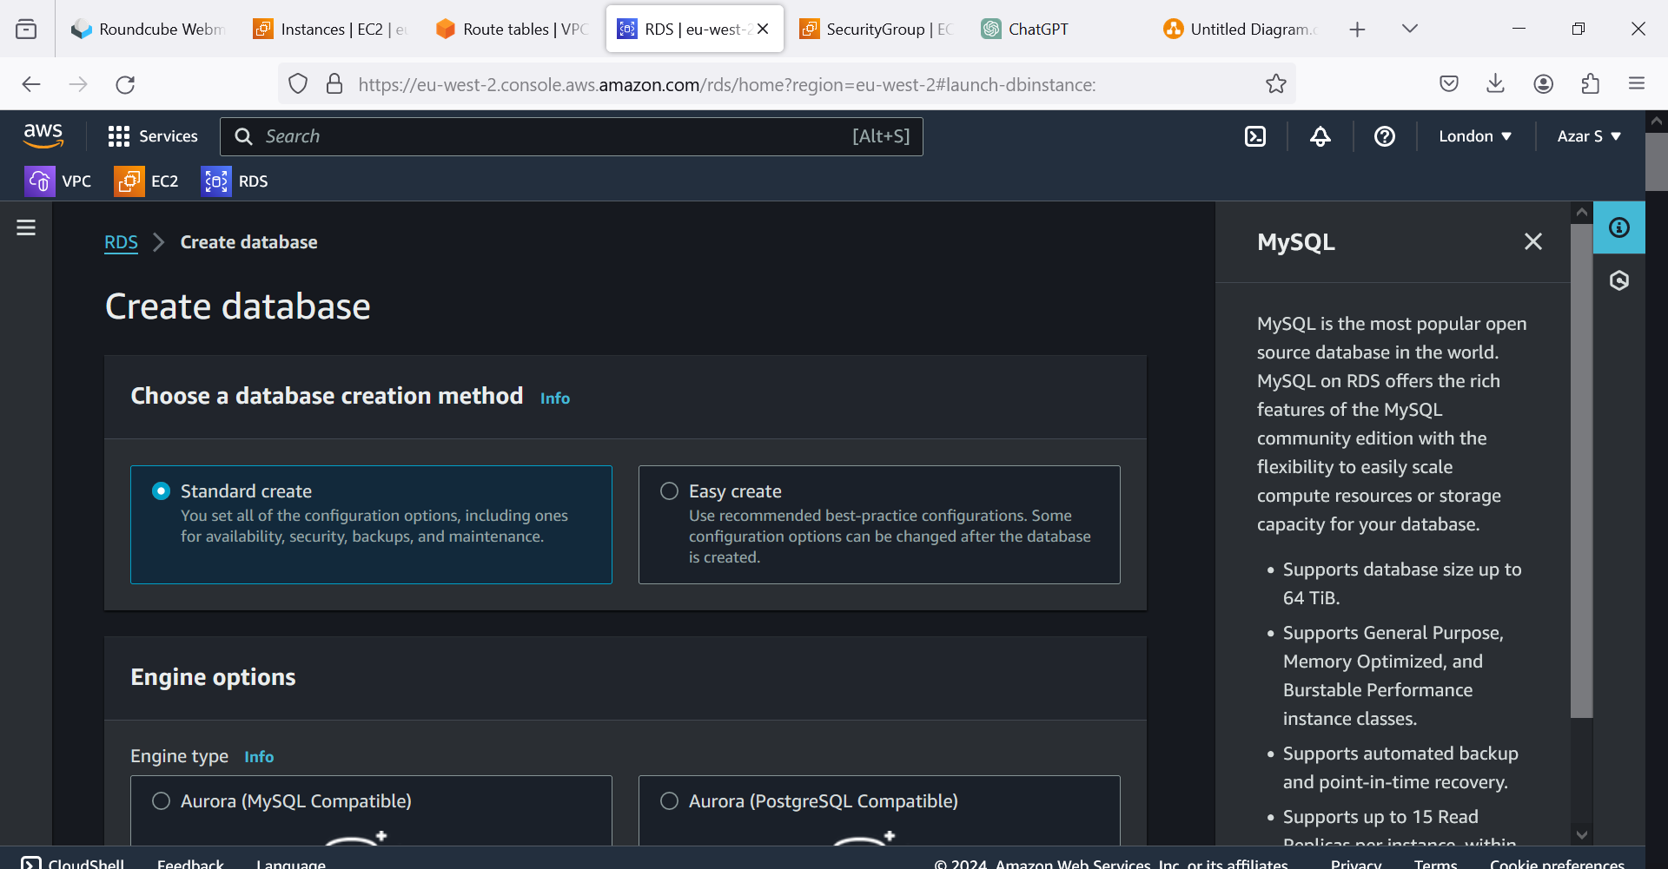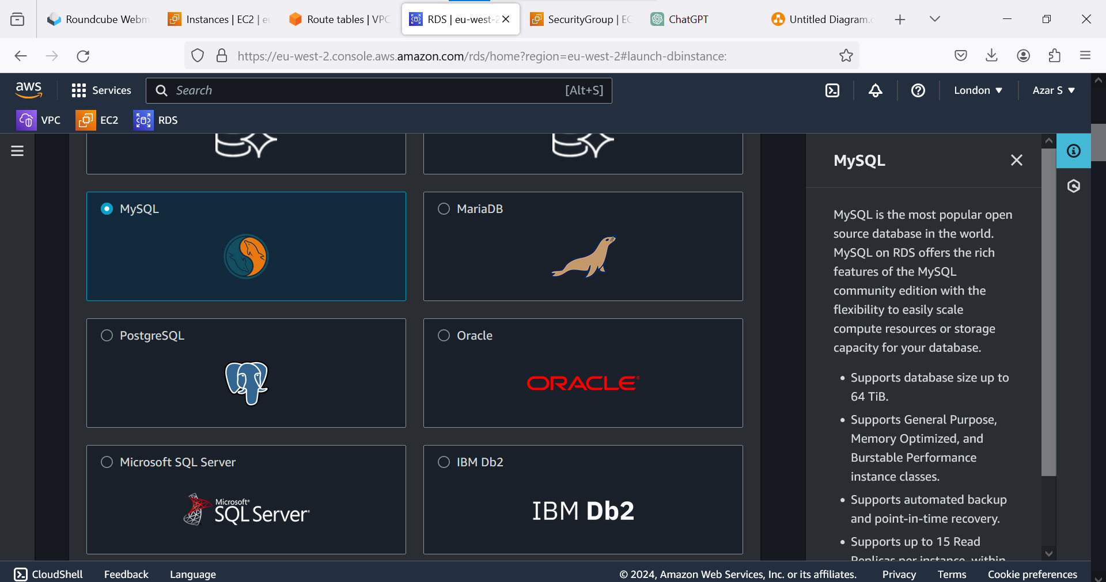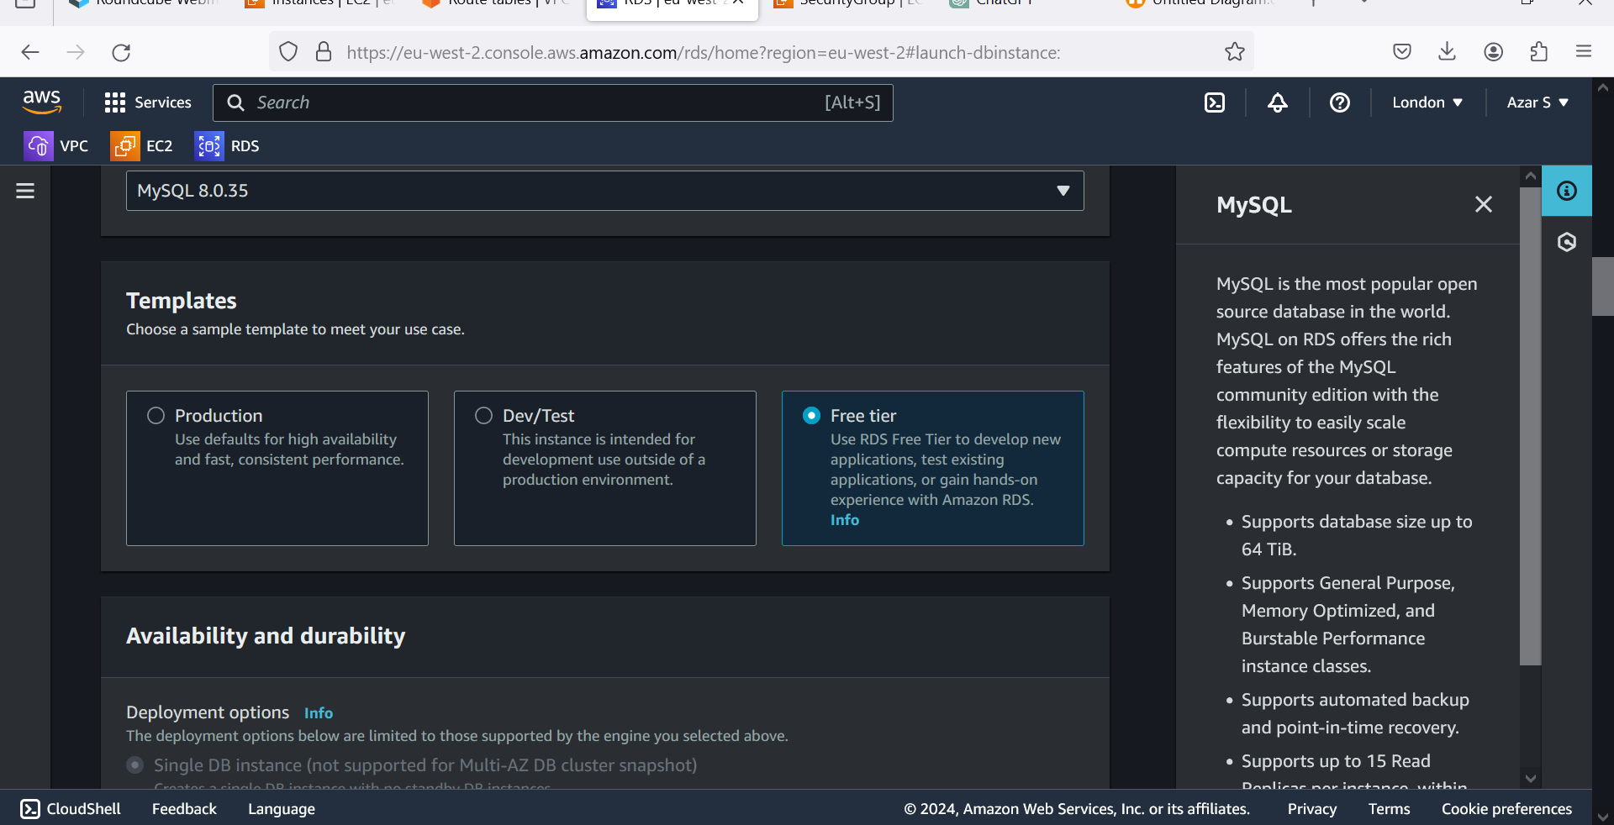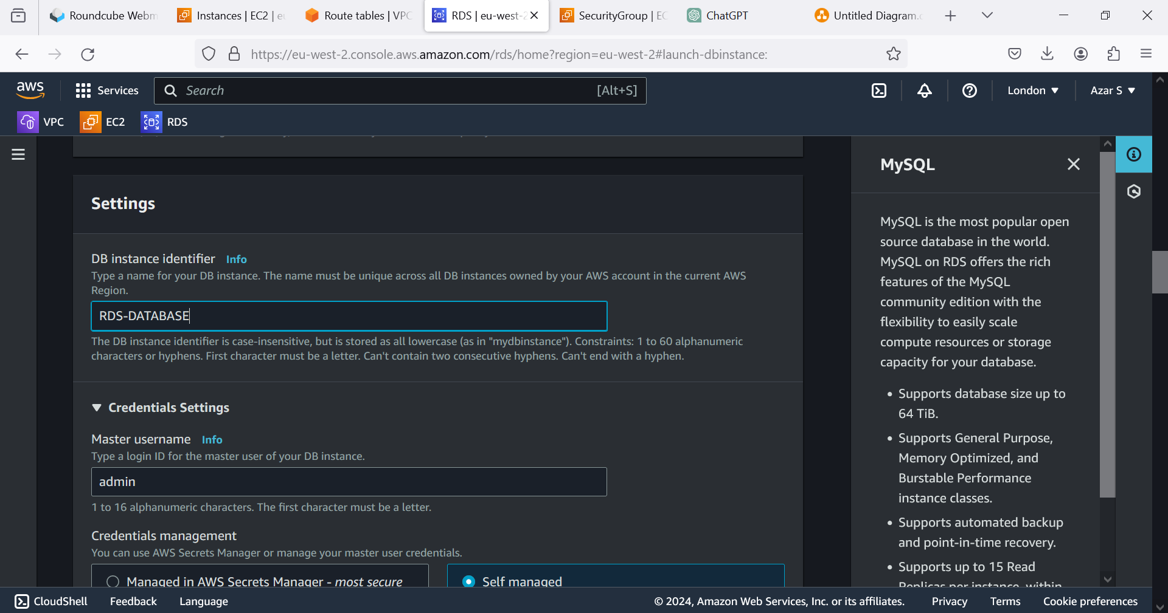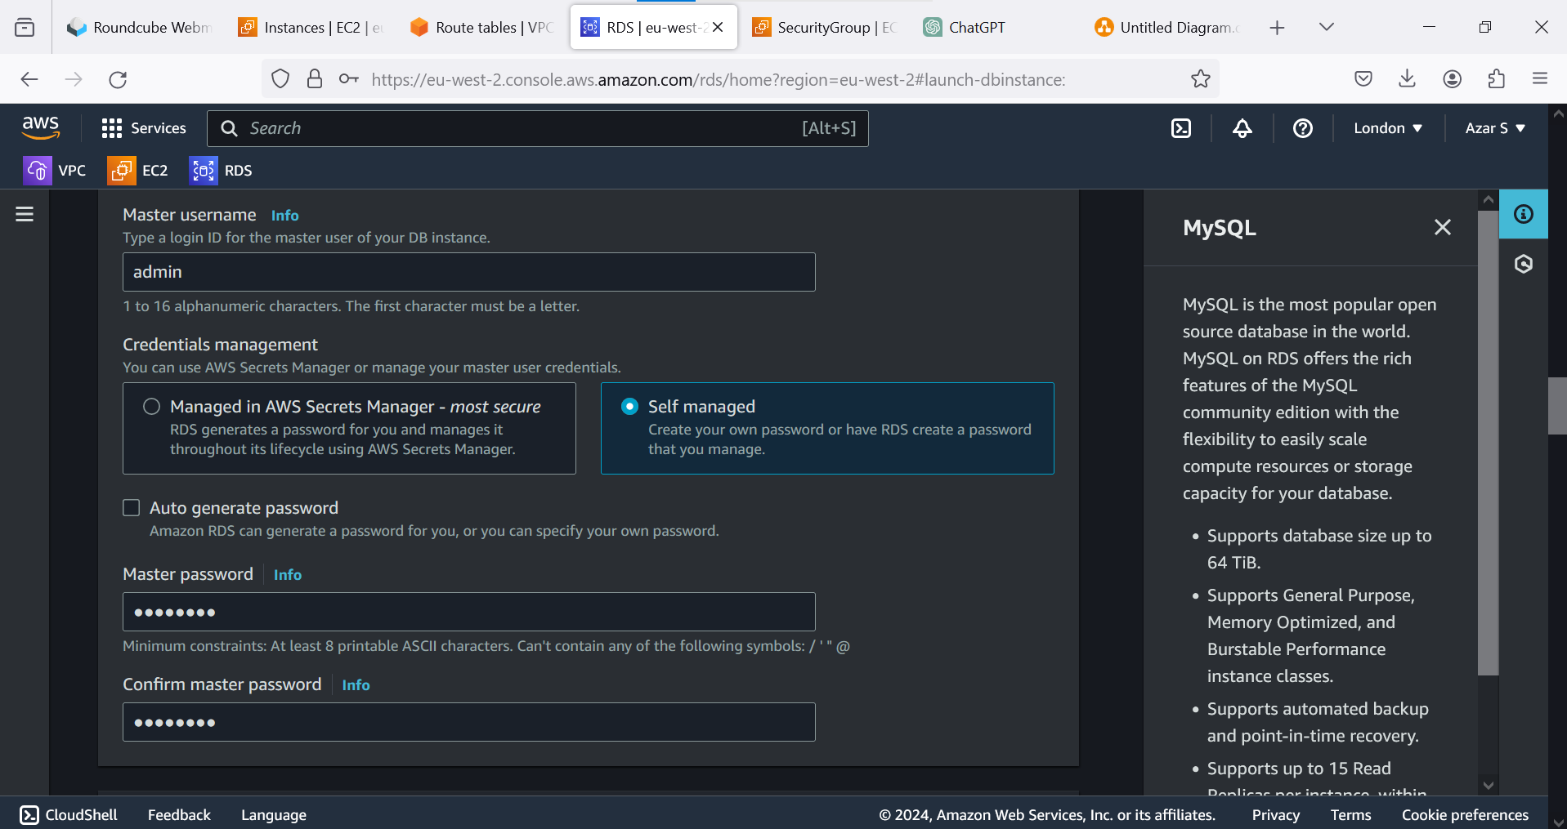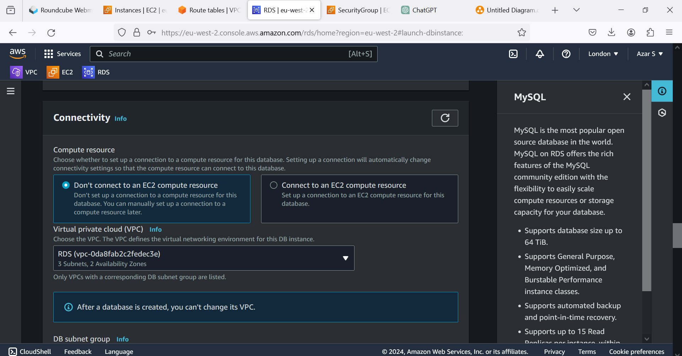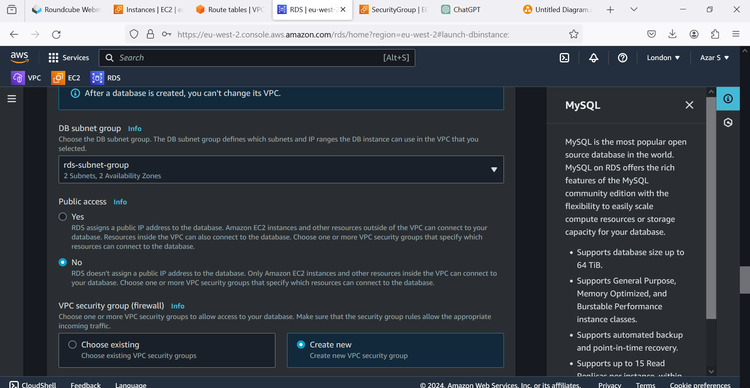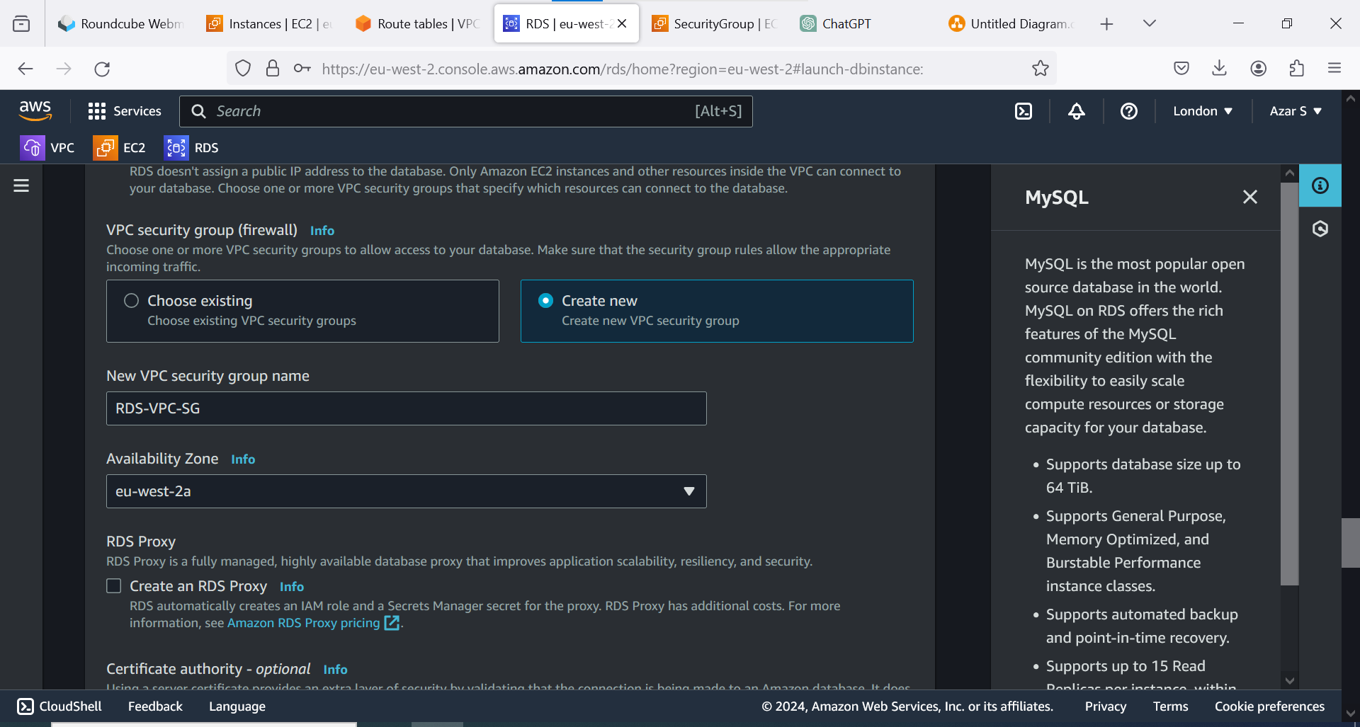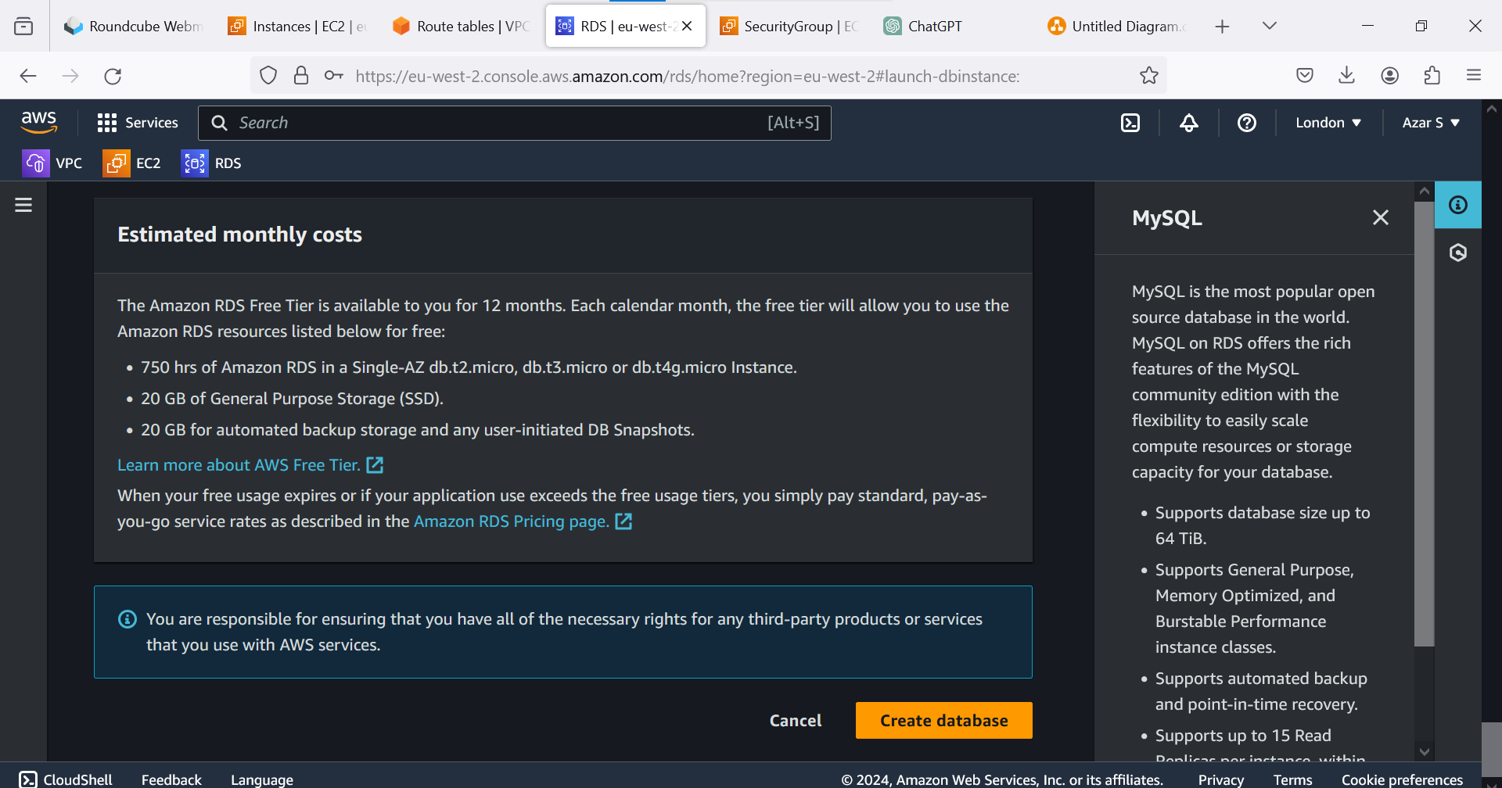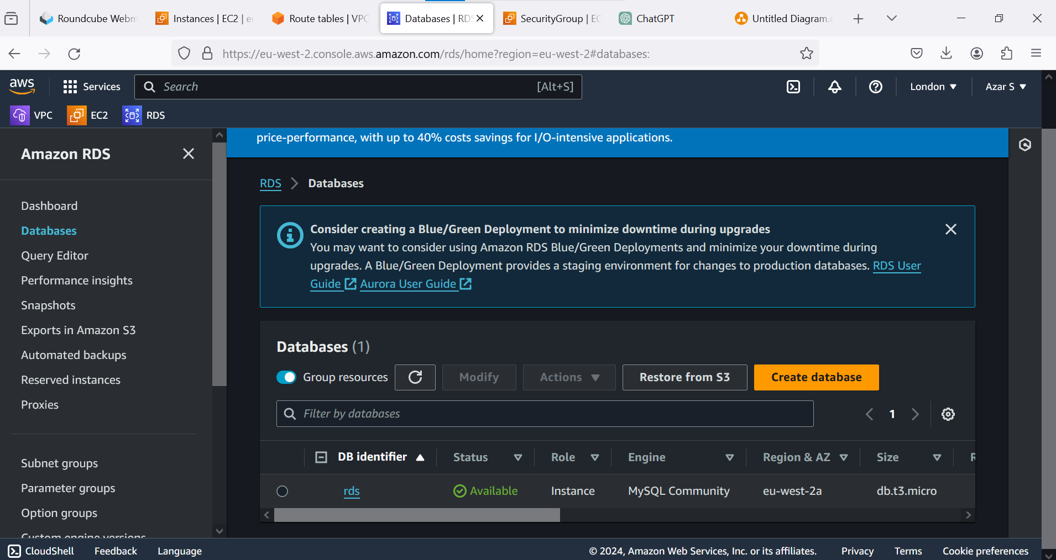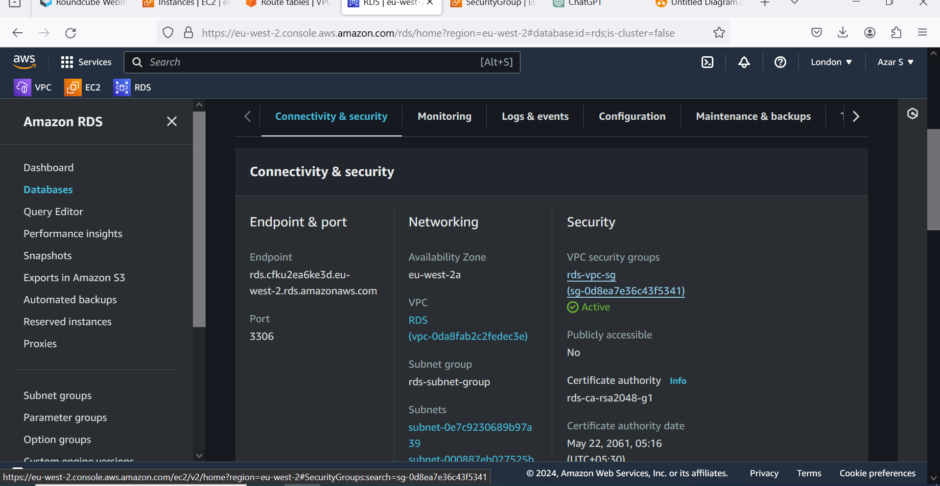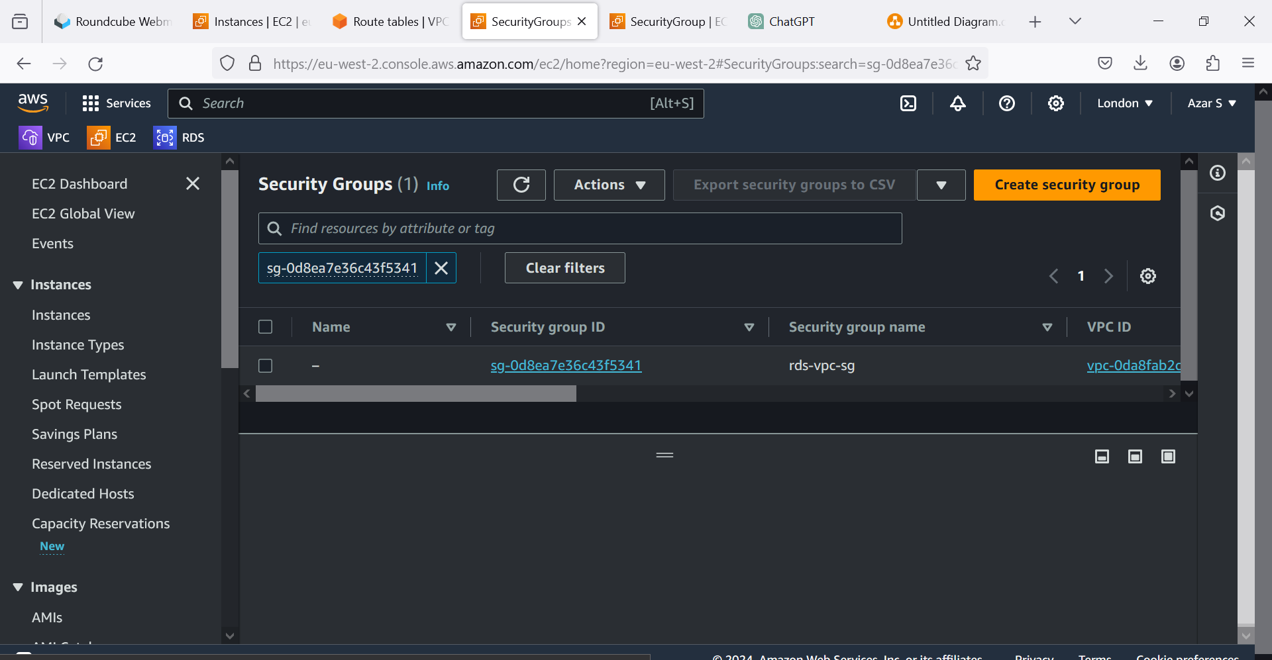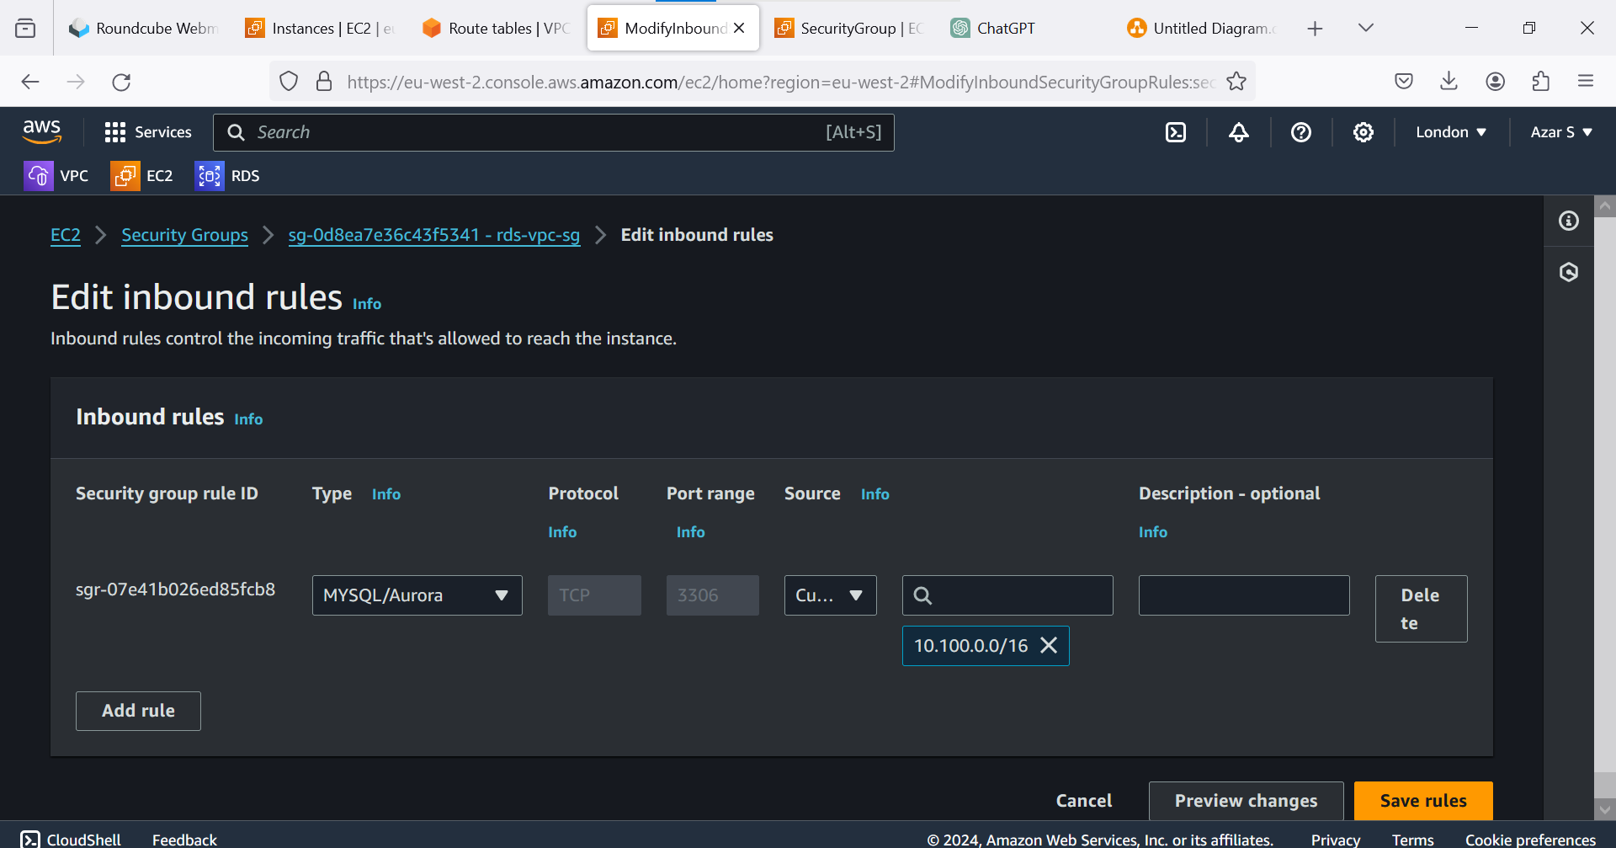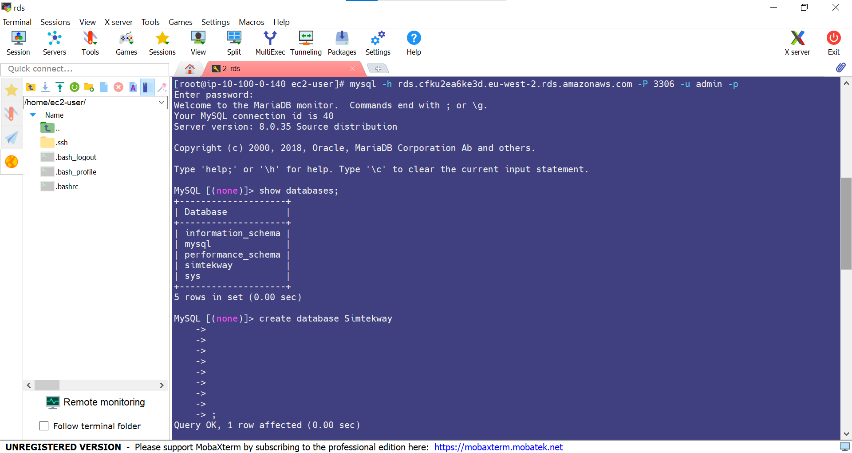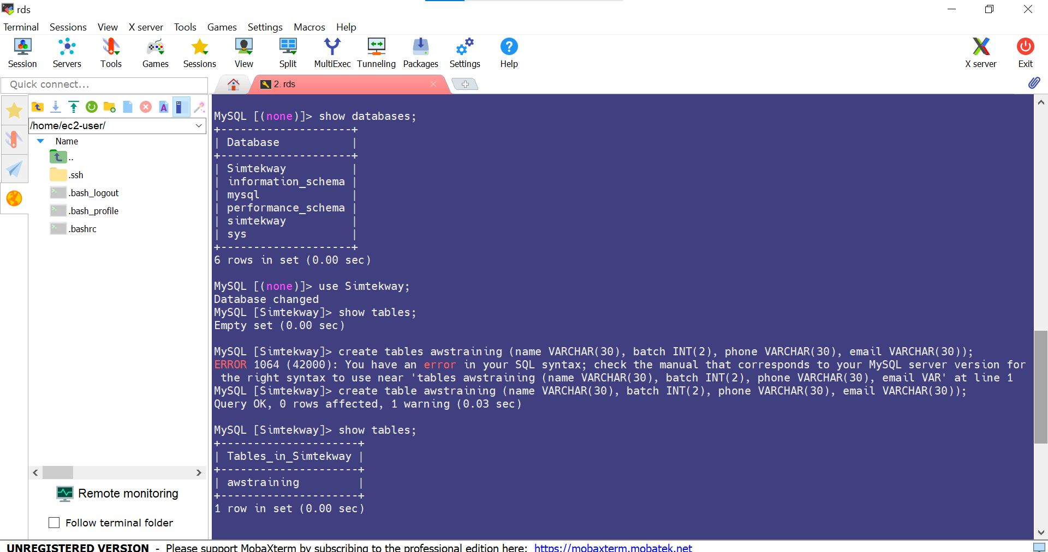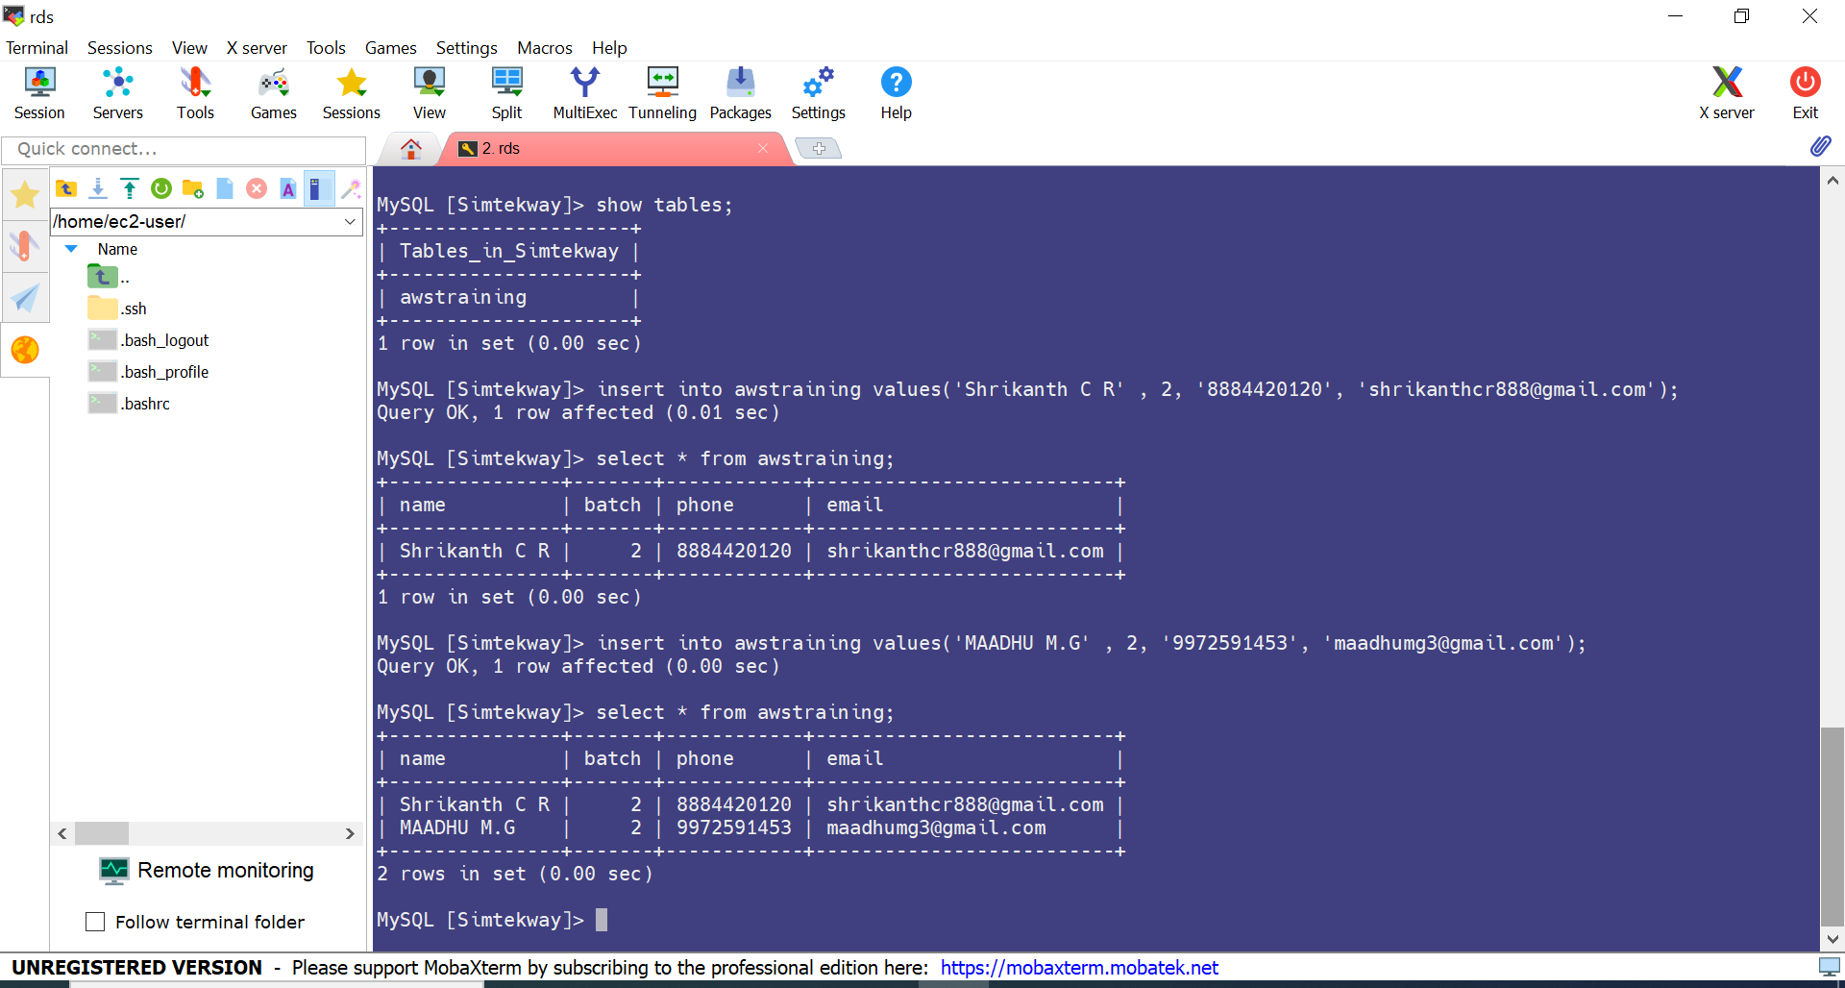

**SQL COMMANDS:**

**Connect with ec2 :**

mysql -h rds.cfku2ea6ke3d.eu-west-2.rds.amazonaws.com -P 3306 -u admin -p admin123

**Create Database:**

create database simtekway:

show databases;

use simtekway;

**Create Table:**

create table awstraining (name VARCHAR(30), batch INT(2), phone VARCHAR(30), email VARCHAR(30));

show tables;

insert into awstraining values('Shrikanth C R' , 2, '8884420120', 'shrikanthcr888@gmail.com');

insert into awstraining values('MAADHU M.G' , 2, '9972591453', 'maadhumg3@gmail.com');

select * from awstraining;

